CIS 111

Summer 2019

Programming Assignment 6

Assigned date: August 5

Due Date: August 12 midnight

1. [20 pts] Turn in two files: toPirate1.html, toPirate1.js

Study this Pirate Glossary:

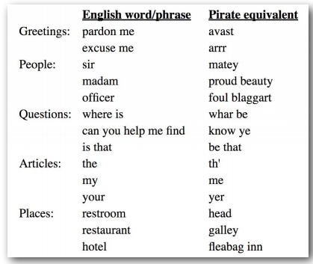

You need to create a pirate dictionary like you see the pirate glossary above. There are five categories given – Greetings, People, Questions, Articles and Places. You just need to create the only the first two categories: Greetings and people. The final output of your work should look like the following image:

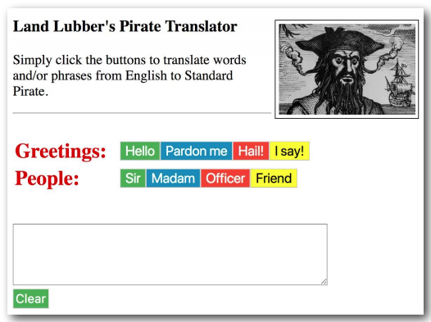

1. Create a table of two columns and two rows. In the first column, put the category names. And in the second column, put the corresponding buttons with the English words. To explain it more precisely, each category (Greetings and People) should be followed by a button group of four buttons for that category.
2. Then you need to add click event listener for each button to append the corresponding pirate word in the text area.

You are also welcome to style (CSS) the web page according to your standards.

1. [40 pts] Turn in files: toPirate2.html, toPirate2.js, toPirate2.css, toPirate2.jpg.

Complete the Pirate Glossary.

1. **Get the files named toPirate2.js, toPirate2.html, toPirate2.css and toPirate2.jpg from canvas’s week 7 module.**
2. Work for the first two rows of the Pirate Glossary is given in the above files. You need to complete the rest of the glossary.
3. Add all English words/phrases and their pirate equivalent in two separate arrays named englishWords and pirateWords given in JavaScript file.
4. Generate the buttons dynamically using JavaScript and the content of the button must be extracted from the englishWords array (as it is done for the first two categories).
5. Each time the buttons are clicked, the pirate equivalent words must be extracted from the second array, pirateWords.
6. the Clear button also need to clean the text area.
7. [40 pts] turn in files: sumOfPDivs.html and sumOfPDivs.js.

A) In Atom, create a file in your p5 folder named sumOfPDivs.html. It should be just a base html code using Emmet package. You just need to include a div element.

B) Create a second file called sumOfPDivs.js that will contain all the JavaScript code, and use a script element in the html page to connect sumOfPDivs.html to sumOfPDivs.js.

C) **Using JavaScript,** add a h2 heading, the text label, a textarea box, and a click button in the div (as shown in the following figure). You need to review the class notes on how to use the createElement, appendChild, and querySelector methods. The styling, such as font sizes and coloring, does not have to be exacting as shown in the figure below.

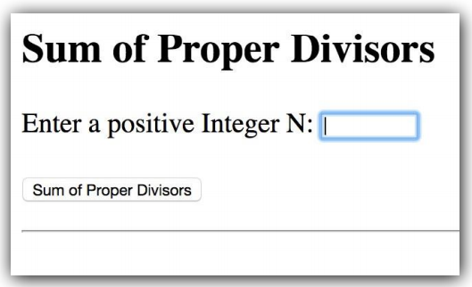

D) Copy a properly working version of your sumOfProperDivisors function from project 5, and paste it into sumOfPDivs.js, near the top of the file. Following this function, define an onclick handler that handles the onclick event.

E) Finally, add the code to register the event handler, at the bottom of the .js file.

F) The completed web app should work like this: When the user enters a number in the text area and then clicks the button, the function result is displayed on the web page, as shown in the following figure:

